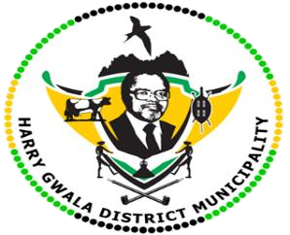**HARRY GWALA DISTRICT MUNICIPALITY**

**“Together We Deliver and Grow”**

**OFFICE OF THE MUNICIPAL MANAGER**

40 Main Street, Private Bag X501, IXOPO 3276

Tel: (039) 834 8700 Fax: (039)834 1701 Email: NgubaneN1@harrygwaladm.gov.za

|  |
| --- |
|  |

**Women’s Celebration**

The Harry Gwala District Municipality together with several Government departments hosted a women's day commemoration program at Bulwer Community Hall - Dr Nkosazana Dlamini Zuma local Municipality.

The purpose of the event was to highlight women empowerment through their line of work. Women from different local Municipalities under the Harry Gwala District had the privilege to showcase their businesses and engage dialogues in the business streams with stakeholders. Amongst other significance the emphasis was on support. Ms Nokzola Khanyile ( Programme Director) encouraged women to support each other and make use of resources provided by government.

To name a few others , Mrs Monica Mkhize a dressmaker based in Sea Ford - Donny Brook said " I received two over lock sowing machines and an industrial iron from the Harry Gwala District Municipality as capital to grow my business, the equipment made my life easier and contributed a great deal into the Business," she also mentioned that the programme held was a prominent way for them as business women to exhibit their work Mrs Nokwanda Nduku and Nombuso Mafuna from Kokstad, Horseshoe implemented their business in 2020 during Covid-19 as the pandemic corned them to express their traditional Art work they shared that such opportunities gave them exposure and engagement to other women in their line of work. On the contrary, love and warmth was shared amongst women throughout the country as they were celebrated with honour and recognition of their hard work and dedication that anything is possible when you set your mind.

ISSUED BY HARRY GWALA DISTRICT MUNICIPALITY COMMUNICATIONS UNIT.