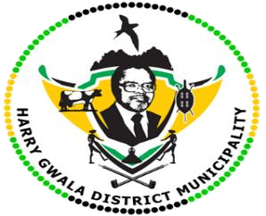**HARRY GWALA DISTRICT MUNICIPALITY**

**“Together We Deliver and Grow”**

**OFFICE OF THE MUNICIPAL MANAGER**

40 Main Street, Private Bag X501, IXOPO 3276

Tel: (039) 834 8700 Fax: (039) 834 1701 Email: NgubaneN1@harrygwaladm.gov.za

|  |
| --- |
|  |

**Harry Gwala District Golden Games.**

Kicking it off with our Senior Citizens at Jeffrey Zungu Sports-Field in Ixopo, where Harry Gwala District Municipality together with KwaZulu-Natal Department of Sport, Arts and culture and other Government stakeholders hosted games on Wednesday (27 August 2024).

It was a fine moment for our Senior Citizens as they were competing, between local Municipalities in the district including UMzimkhulu, UBuhlebezwe, Dr. Nkosazana Dlamini Zuma and Greater Kokstad. This initiative aims to keep our seniors vibrant & fit in our society because with some, as they age, they seem to develop chronic illnesses. One of the participants, Mr Linda Khumalo a 62-year-old 400m runner from Pholela said this is his second year in the program, he mentioned that he now trains daily to maintain.

"I am so happy as this has changed my lifestyle, I have adopted new healthy habits which result in maintaining a good health record, Previously I had health issues one of them being blood pressure. This program has helped me a great deal in regard to my mind set. I'm always motivated to do better and take wise decision regarding my health" said Mr Khumalo.

We also shared a moment with Mr. Johannes Ngubo, (71 years) who has been a shooting ball player for a year according to him, such games restore their vitality as they feel younger and rejuvenated:" I wish this program could be an ongoing event throughout the year so that we keep training and motivated,” said Ngubo.

The games ended on a high note as His Worship the District Mayor Cllr. Z. D Nxumalo celebrated this day with the senior Citizens, he also encouraged them to continue participating in the program as it ensures a good healthy lifestyle. Other councilors also attended the games and wished the senior citizens well. Those who were successful will represent the District in the Provincial games to be hosted soon.

ISSUED BY HARRY GWALA DISTRICT MUNICIPALITY COMMUNICATIONS UNIT.