Harry Gwala District Municipality

MFMA s71 report for the period ending 31 January 2024.



**In-Year Report of the Municipality**

Prepared in terms of Section 71 & Section 52 (d) of the Local Government Municipal Finance Management Act, (Act 56 of 2003) and the Municipal Budget and Reporting Regulations, Government Gazette 32141, 17 June 2009.

Table of Contents

1.2 Executive Summary 6

1.3 Resolutions 10

1.4 Monthly Budget Statement Tables 10

2.1 Debtors Analysis 20

2.2 Creditors Analysis 26

2.3 Investment Portfolio Analysis 26

2.4 Allocation and Grant receipts and Expenditure 27

2.5 Councillor and Staff Benefits 29

2.6 Material Variances to the SDBIP 31

2.7 Municipal Manager’s Quality’s Certificate 42

**Glossary**

**Adjustments budget –** Prescribed in section 28 of the MFMA. The formal means by which a municipality may revise its annual budget during the year.

**AFS** – Annual Financial Statements

**Budget –** The financial plan of the Municipality.

**Capital expenditure -** Spending on assets such as infrastructure, land & buildings minor assets etc. Any capital expenditure must be reflected as an asset on the Municipality’s statement of financial position.

**DORA –** Division of Revenue Act. Annual legislation that shows the total allocations made by national to provincial and local government.

**Equitable share –** An unconditional grant paid to municipalities. It is predominantly

targeted towards funding the Indigent Policy.

**FMG** – Financial Management Grant.

**GRAP –** Generally Recognised Accounting Practice. The standard for municipal

accounting.

**IDP –** Integrated Development Plan. The main strategic planning document of the

Municipality.

**MBRR –** Local Government: Municipal Finance Management Act (56/2003): Municipal budget and reporting regulations.

**MFMA –** Local Government: Municipal Finance Management Act (56/2003). The principle legislation relating to municipal financial management.

**MIG** – Municipal Infrastructure Grant.

**MTREF –** Medium Term Revenue and Expenditure Framework (MTREF). The medium term financial plan, usually 3 years, based on a fixed first year and indicative further two years budget allocations. Also includes financial information of the previous and current year.

**Operating expenditure –** Spending on the day to day expenses of the Municipality such as salaries and wages, repairs and maintenance etc.

**SDBIP –** Service Delivery and Budget Implementation Plan (SDBIP). A detailed plan

comprising annual and quarterly performance information. Harry Gwala District Municipality MFMA s71 Monthly Report Page 5

**Strategic objectives –** The main priorities of the Municipality as set out in the IDP.

Budgeted spending must contribute towards the achievement of the strategic objectives.

**Vote –** one of the main segments into which a budget of a municipality is divided for the appropriation of money for the different departments or functional areas of

the municipality; and which specifies the total amount that is appropriated for the purposes of the department or functional area concerned. .

**YTD –** Year to date

**YoY –** Year on Year

**DBSA** – Development Bank of South Africa

**PURPOSE**

To table a report on the Implementation of the current budget and the financial state of the Municipality in terms of Section 71 of the Municipal Finance Management Act (MFMA)

**LEGISLATIVE FRAMEWORK**

* Local Government: Municipal Finance Management Act, 56 of 2003
* SCM Regulations
* SCM Policy
* Municipal Budget Reporting Regulation
* Division of Revenue Act

**Legislative Requirements**

In terms of the section 71 of the MFMA the accounting officer of a municipality must by no later than 10 working days after the end of each month submit to the Mayor of the municipality and the relevant provincial treasury a statement in the prescribed format on the state of the municipality’s budget reflecting the following particulars for that month and for the financial year up to the end of that month:

*(a)* Actual revenue, per revenue source;

*(b)* actual borrowings;

*(c)* actual expenditure, per vote;

*(d)* actual capital expenditure, per vote;

*(e)* the amount of any allocations received;

*(f)* actual expenditure on those allocations, excluding expenditure on—

(i) its share of the local government equitable share; and

(ii) allocations exempted by the annual Division of Revenue Act from compliance with this paragraph; and

*(g)* when necessary, an explanation of—

(i) any material variances from the municipality’s projected revenue by source, and from the municipality’s expenditure projections per vote;

(ii) any material variances from the service delivery and budget implementation plan; and

(iii) any remedial or corrective steps taken or to be taken to ensure that projected revenue and expenditure remain within the municipality’s

## 1.2 Executive Summary

This report is a summary of the main budget issues arising from the in-year monitoring process. It compares the progress of the budget to the projections contained in the Service Delivery and Budget Implementation Plan (SDBIP).

**Revenue by Source**

The Year-to-Date actual revenue is 118% above the YTD budget. All the allocated conditional grants receipted as per Division of Revenue Bill, However the recognition as revenue only occur when the expenditure is incurred.

**Borrowings**

The balance of borrowings does not have the long term loans.

**Operating expenditure by vote & type**

The total operating budget for the current year amounts to R684, 1m. The YTD Operating expenditure for the month ended 31 January amounted to R351, 6m against a year to date (YTD) budget of R399m. The actual YTD expenditure represented 88% of the year to date budget.

**Capital expenditure**

The total capital budget for the current year amounts to R306, 1m. The YTD expenditure on capital amounts to R188, 7million against year to date budget of R178, 5million, or 106% of the planned expenditure. Capital expenditure is mainly funded by means of National grants.

**Chart 1: Budget vs. Expenditure Summary**

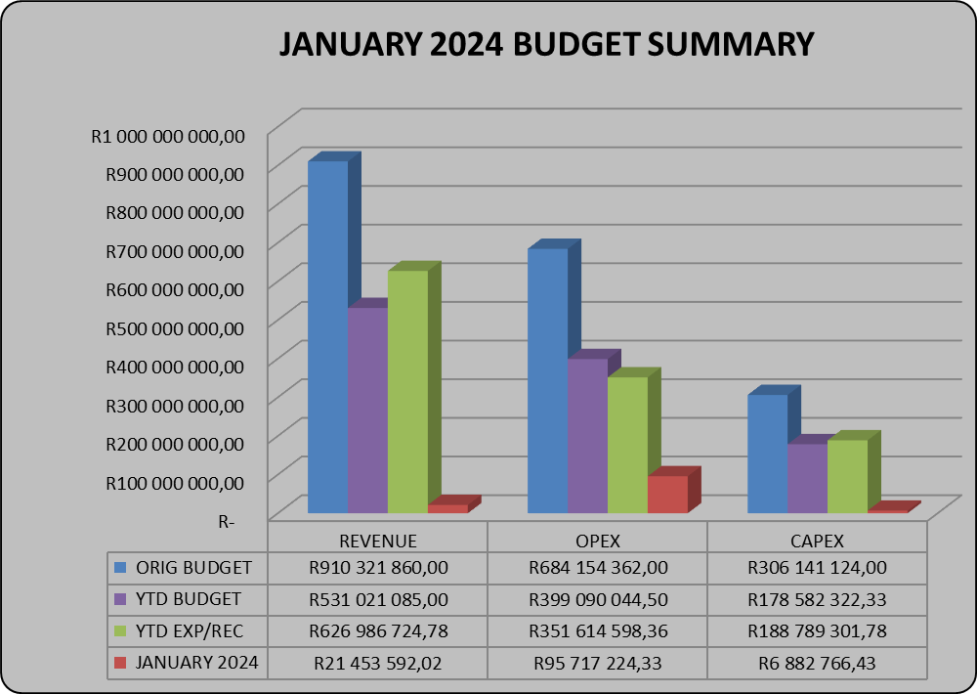

**Cash flows**

The municipality started the year with a positive cashbook balance of R124, 6million. The closing cash and cash equivalents as at the end of January 2024 was R329, 2million.Refer to the table below for cash and cash equivalent register for more detail on the cash position.

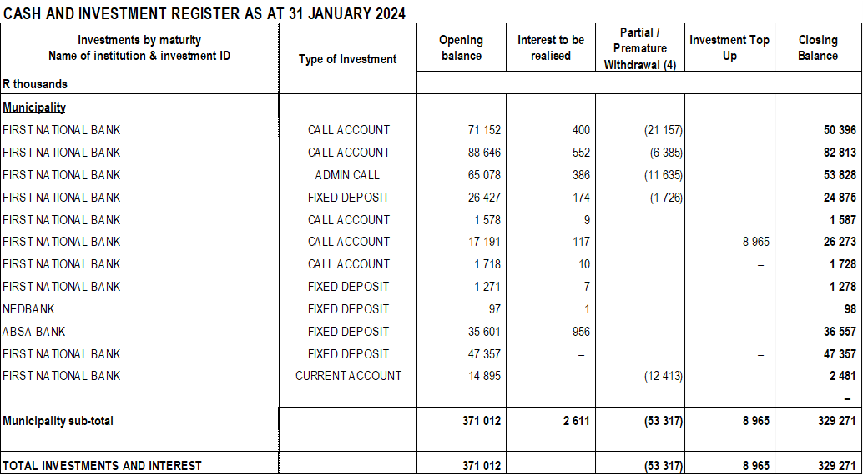

**Allocations received (National & Provincial Grants)**

All DORA and provincial grants allocations for 2023/2024 have been received as per payment schedule. The total grants received as at 31 January 2024 was R 636, 9million.Conditional Grants amounting to R 289, 1million and the equitable share is R 347, 7million. No grant received in the month ending 31 January 2024

**Spending on Grants**

Spending on grants amounted to R188, 7million or 106% for the month ending January 2024.

## Resolutions

This report will be tabled to Executive committee and therefore the resolution will be available once it tabled to council in terms of Sec 52 (d) of the MFMA.

## Monthly Budget Statement Tables

**Monthly Budget Statements Summary**

Table C1 below provides a summary of the overall performance in the Municipality and is unpacked in the sections that follow.



**Financial Performance**

Table C2 provides the statement of financial performance by standard classification.



This table assess the revenue by department and then the expenditure for the period ending 31 January 2024. Revenue receipts in January have largely constituted of service charges which is water and sanitation. The overall budgeted revenue cash receipt for the month of January is 4% against original budget.

Expenditure by standard classification presents the expenditures by the departments. Infrastructure Services Department has the largest expenditure for the month of January due to depreciation followed by Water Services Department as the department responsible for the repairs and maintenance of the municipal assets and with the largest staff complement, shares the greatest bulk of this budget and hence the expenditure of R24, 2million.

Table C3 presents the same information as the table above, the difference being that it’s by Municipal vote.



**Statement of financial Performance**

This schedule provides information on the planned revenue and operational expenditures against the actual results for the period ending 31 January 2024.



**Capital Expenditure**

Table C5 below reports on the capital expenditures by departments (municipal vote) and by standard classification. The bottom part of the schedule looks at the funding sources of the capital projects.



As alluded to above, the capital expenditure programme for the period ending 31 January 2024 was R188, 7m which represents 106% of capital expenditure against year to date budget of R178, 5million.

The chart below presents a high level analysis of YTD capital expenditure budget against the YTD actual expenditure.

**Chart 1: 2023/2024 CAPEX**

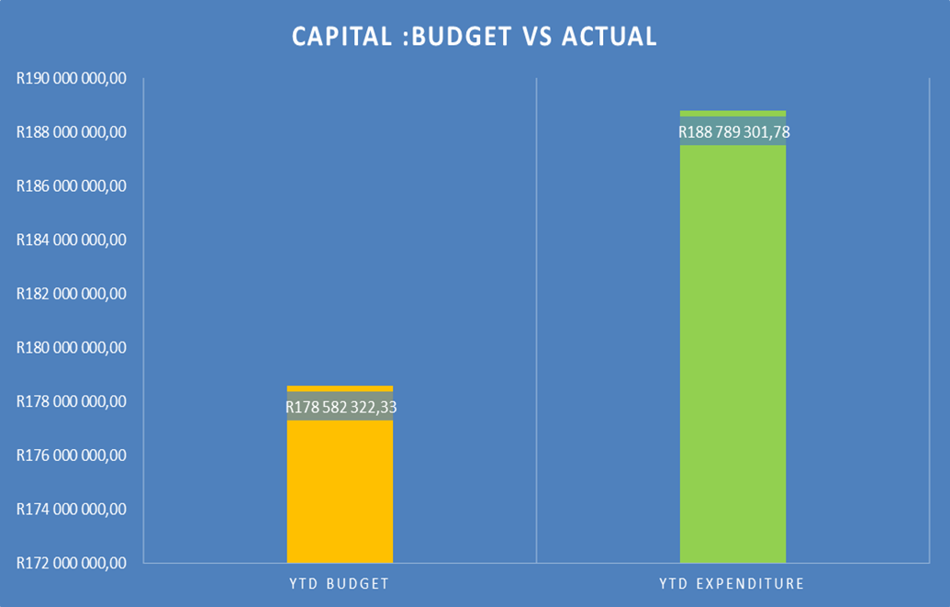

Table C6 displays the financial position of the municipality as at 31 January 2024.



Table C7 below display the Cash Flow Statement for the period ending 31 January 2024.



**PART 2 – SUPPORTING DOCUMENTATION**

## Debtors Analysis

The table presented below summarises the Debtors Age Analysis as at 31 January 2024.

**Table 2.1.1: Debtors Age Analysis by Income Source**



The municipal consumer debt is currently decreasing as the municipality implementing amnesty and installing prepaid meters as it has a direct impact on municipal cash flows.

**Chart 2: Debtors Age Analysis by Customer Group**

The information presented in the chart above ranks total debt owed to the municipality from highest to the lowest,

* Households: 81%
* Government 12%
* Business 7%

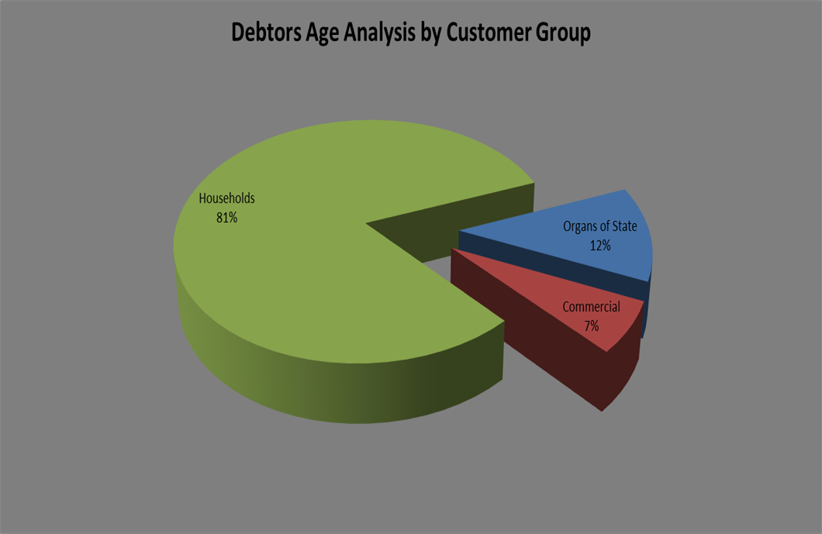

The chart above shows that for each debtor type the amounts owing to the municipality have increased on a year to year basis.

The table that follows below unpacks the revenue receipts per Local Municipality in the District

**Revenue receipts per Area**

|  |  |  |
| --- | --- | --- |
| AREA | AMOUNT |  |
| **JANUARY 2024** | **DECEMBER 2023** |
| Unallocated receipts | R 52 034 | 2% | 1% |
| Bhongweni | R 25 905 | 1% | 0% |
| Shayamoya | R 33 258 | 1% | 0% |
| Kokstad | R 581 076 | 21% | 47% |
| Ixopo | R 761 608 | 28% | 12% |
| NDZ | R 530 540 | 20% | 21% |
| Umzimkulu | R 724 570 | 27% | 20% |
| Fairview | R 4 637 | 0% | 0% |
| TOTAL RECEIPTS INCL VAT | **R 2 713 628** | 100% | 100% |

The table above presents the cash receipts from consumer debtors in each of the detailed areas as well as the comparative receipts for the previous month. The total cash collected for January 2024 is R2, 7million. The collection for prepaid in the month of January is R 416 034. Total cash collected including prepaid for the month ending 31 January is R 3,129,662.

Billing vs Collection trend for January 2024.

The chart that follows below shows the comparison between billing and collection trend for the period ending 31 January 2024.

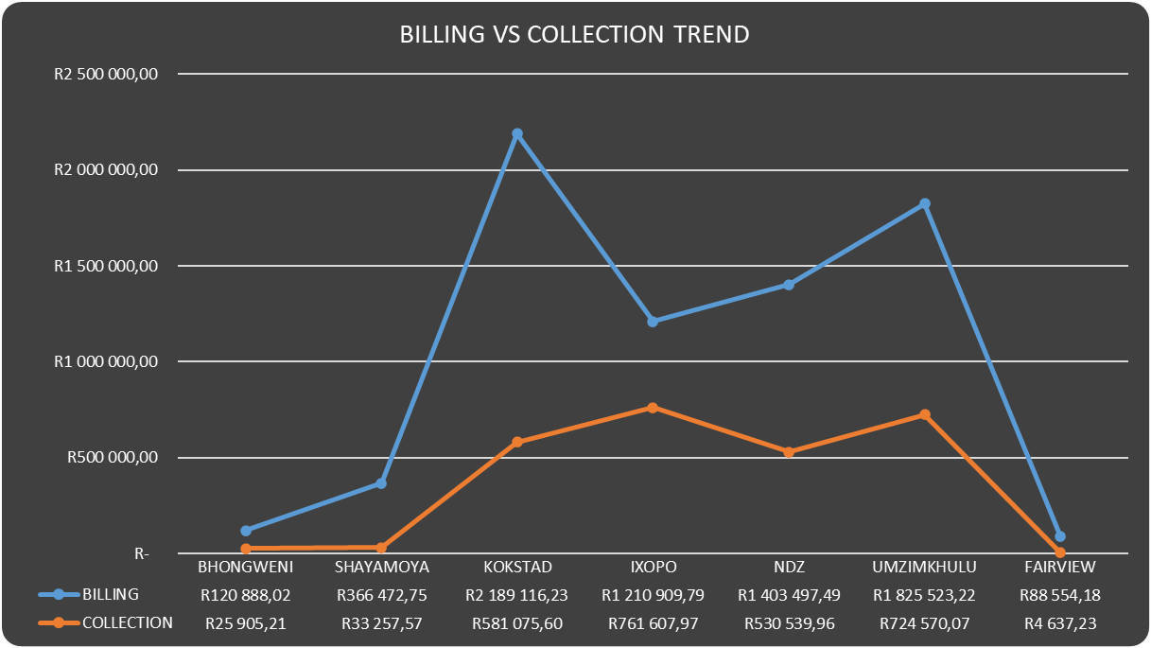

The chart that follows below shows the comparison between billing and collection for the period ending 31 January 2024

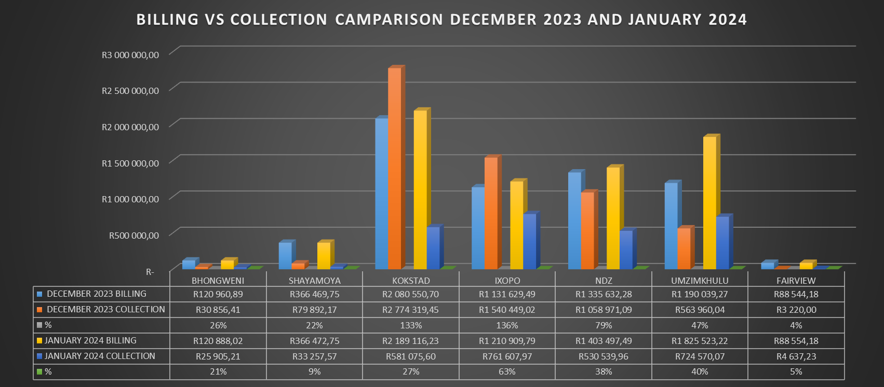

**Debtors age analysis per service**

The municipality’s total outstanding debtors amounted to R 253,319,761 as at 31 January 2024 compared with the R 247,694,050 as at 31 December 2023. Current debt represents 4% of the total outstanding debt compared with the 2% of December 2023; 30 days and older debt 2% compared with the 2% for December 2023; 60 days and older debt 2% compared with the 2% of December 2023; and 90 days 2% compared with the 1% of December 2023; 120 days to History and older 91% compared with the 92% for November 2023.

Current debt increased with R 866,508 to R 253,319,761 in the month ending 31 January compared with the R 247,694,050 as at 30 November 2023; 30 days + debt decreased with R 424,086; 60 days + increased with R 177,231; 90 days + debt increased with R 222,587 and 120 + days and older debt as at 31 December 2023 has increased with R 3,368,605 to R 230,636,649 compared with the R 227,268,044 for December 2023.

**Debtors age analysis per debtor type**

Business debtors owes the municipality R 16,081,248 (6%); Municipal debtors R 996,623 (0%); domestic debtors R 186,614,278 (74%); Government accounts R 29,777,161 (12%); Indigent debtors R 13,920,109 (5%); Deceased R 855,400 and other debtors R 5,075,093 (2%) of the total outstanding debt of R 253,319,761.

## Creditors Analysis

Table SC presents the aged creditors as at 31 January 2024



## Investment Portfolio Analysis

The following information presents the cash at bank and short term investments balances broken down per investment type as at 31 January 2024.



## Allocation and Grant receipts and Expenditure

Table SC 6 displays information relating to grant receipts.



It is clear from the chart above that the bulk of the grants received by the municipality are from the National Treasury.

Table SC7 track the expenditure on Conditional grant funding.



**CONDITIONAL GRANTS REGISTER AS AT 31 JANUARY 2024**

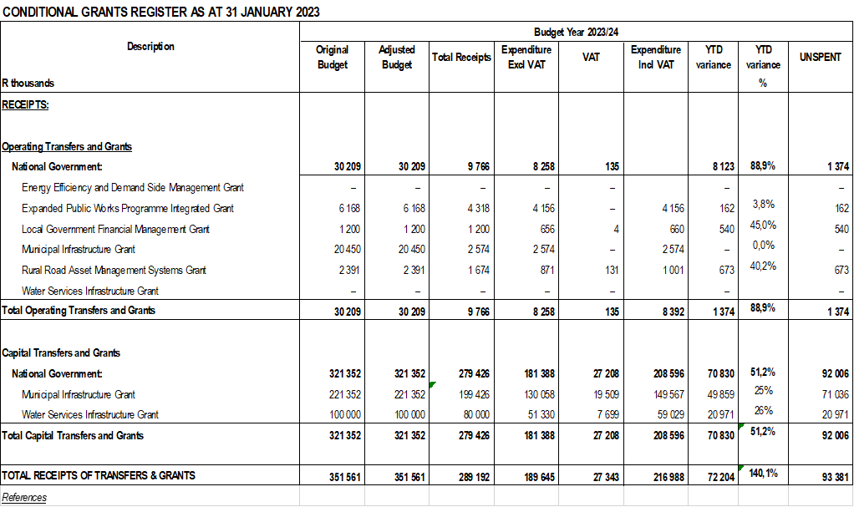

The YTD actual on conditional grants amounts to R216, 9million against a YTD receipt of R289, 1million.The unspent as at 31 January 2024 is sitting at R93, 3million. The percentage spent on capital conditional grants is 51, 2per cent. The Municipal Infrastructure Grant is at 62 per cent as at 31 January 2024 and Water Services Infrastructure Grant is also sitting at 59 per cent expenditure as at 31 January 2024.

## Councillor and Staff Benefits

Table SC8 presents the expenditure of councillor and staff benefits at 31 January 2024.



## Material Variances to the SDBIP

The following section analyses material variances between the actual targets as at 31 January 2024 and the budget for the same period. This report analyses each major component under following headings;

* Revenue by Source
* Operational Expenditure by Type, and
* Capital Expenditure
* Financial Position
* Cash Flows

**REVENUE**

The chart displays a comparison between the 202324 financial year revenue budget and the performance against this budget as depicted in the form of Year to date (YTD) Actual figures. It should be emphasised that the information presented relates to “performance” rather than “cash movements” in terms of the revenue items listed below. This accounting principle relating to municipal performance is best illustrated in the analysis that follows.

**Chart 3: Revenue Analysis**

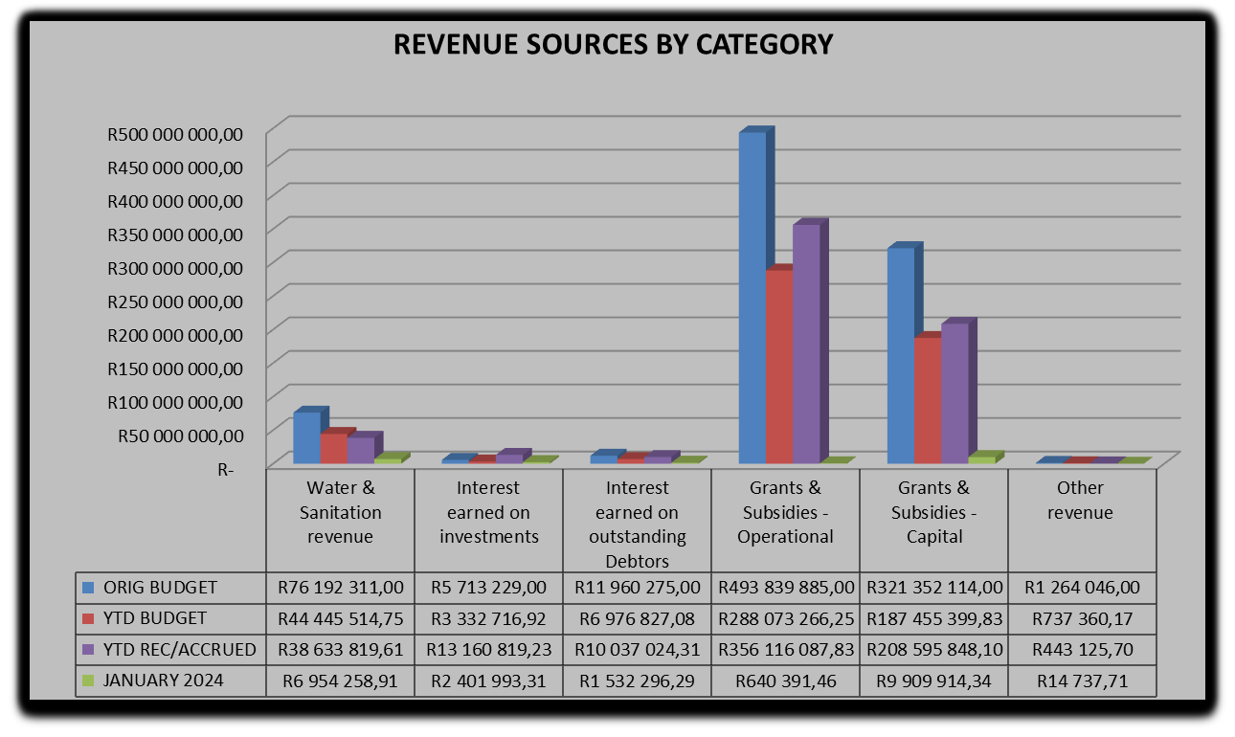

**Water & Sanitation Charges**

The year to date **actual** water & sanitation charges **(billing)** as at 31 January 2024 was R38, 6million against a year to date **budget** of R44, 4million which is 87 per cent of year to date budget.

**Interest Earned on External Investments**

The interest earned on external investments year to date actual is R13, 1m against year to budget of R3, 3m representing 395 per cent of the year to date budget.

**Transfers Recognised - Operational**

The operational grants revenue of R356, 1million against a year to date budget of R288million is largely attributable to the YTD equitable share received.

**Transfers Recognised – Capital**

The total capital budget for the current year amounts to R321, 3million. The YTD actual on capital amounts to R208, 5million against a YTD budget of R187, 4million or 111% of the planned expenditure. Capital expenditure is mainly funded by means of National grants.

**Other Revenue**

The YTD performance of other revenue is R 443 126 against YTD budget of R 737 360 which is made up of tender documents and clearance certificates.

**OPERATIONAL EXPENDITURE**

The chart below presents the YTD operational expenditure movements against the YTD budgets. An analysis of each expenditure line item category is discussed below.

**Chart 4: 2023/24 financial year Opex**

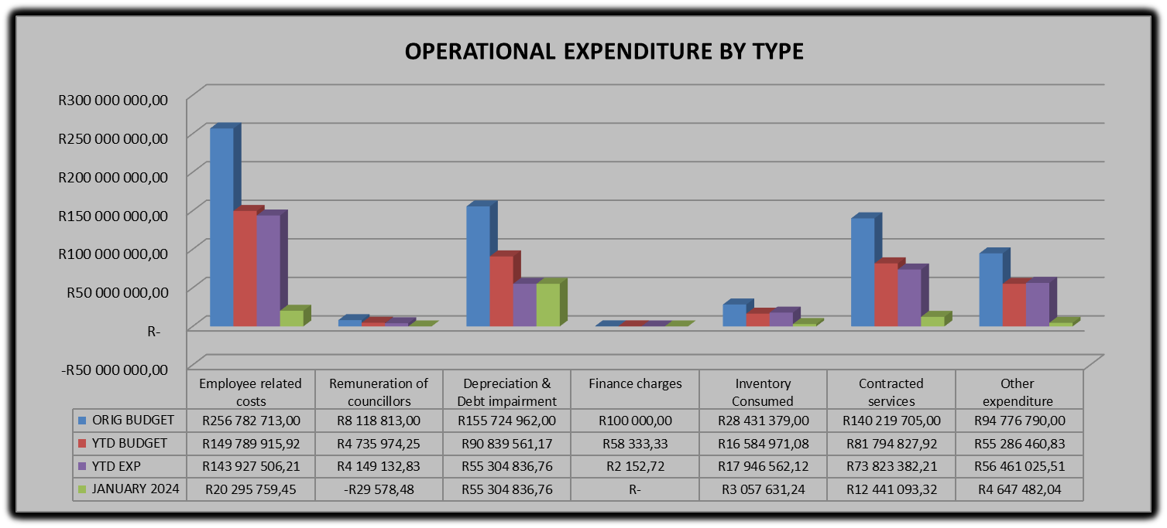

**Employee Related Costs**

The YTD actual for employee related costs is R143, 9million against a YTD budget of R149, 7million which is 96% of the YTD budget.

**Remuneration of Councillors**

The remuneration of councillor’s year to date expenditure is at R4, 1m against a YTD budget of R4, 7m representing 88% of the year to date budget.

**Finance Charges**

The YTD budget for finance charges is R58 333 against a YTD actual of R2 152 which is 4% of the YTD budget. There was no movement in the month ending January 2024.

**Inventory Consumed**

The inventory consumed has the original budget of R28, 4m. The year to date expenditure for inventory is R17, 9m against a YTD budget of R16, 5million representing 108 per cent expenditure of the year to date budget.

**Contracted Services**

The original budget for contracted services is R 140, 2milllion. The year to date expenditure for Contracted Services is R73, 8m against a YTD budget of R81, 7million representing 90 per cent of planned expenditure.

**Other Expenditure**

The YTD budget for other expenditure was at R55, 2milllion against a YTD expenditure of R 56, 4million or 102 per cent and expenditure for the month of January 2024 is R 4, 6million.

**Performance assessment**

The Performance Assessment Report will be available on the fourth quarter in terms of Sec 52 (d) of the Municipal Finance Management Act.

**Actual and revised targets for cash receipts**



**Capital Expenditure Trend**



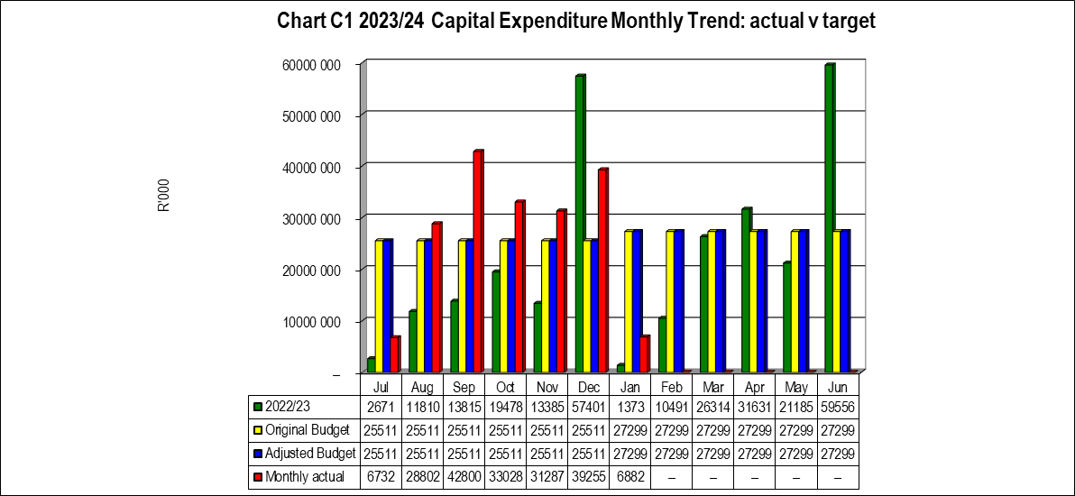

**Capital Expenditure on New Assets by Asset Class**



**Capital Expenditure on Renewal of Existing Assets by Asset Class**



**Expenditure on Repairs and Maintenance by Asset Class**



## 2.7 Municipal Manager’s Quality’s Certificate

Quality Certificate

I, Gamakulu Ma’art Sineke, the Municipal Manager of Harry Gwala District Municipality, hereby certify that-

* The monthly budget statement

For the month of January 2024 has been prepared in accordance with the Municipal Finance Management Act and regulations made under that Act.

Print name: Gamakulu Ma’art Sineke

Municipal Manager of: Harry Gwala District Municipality

Signed____________________

Date______________________